AWS RDS Database Deployment and SQL Management
Deployed a fully managed relational database on Amazon RDS (Aurora/MySQL), configured secure connectivity from an EC2 Linux instance, designed relational tables, and executed SQL queries including joins.
Overview
Goal: Provision an Amazon RDS database, securely connect to it from an EC2 instance, design a normalized schema, and query relational data.
Primary AWS services: Amazon RDS (Aurora/MySQL), Amazon EC2 (Linux), VPC Security Groups, SSH
Architecture
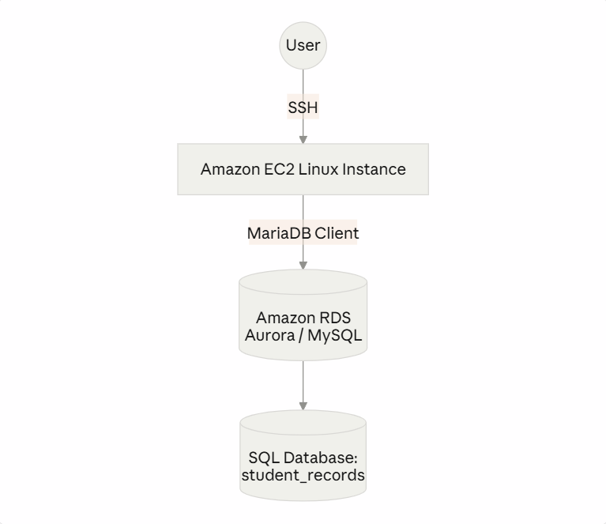
What I implemented
1. Provisioned Amazon RDS Created an Amazon Aurora/MySQL database using a Dev/Test template, db.t3.micro instance class, General Purpose SSD storage, deployed into a custom Lab VPC with a dedicated security group.
2. Configured secure connectivity Updated Security Group inbound rules to allow the EC2 instance to reach the RDS instance, then connected to EC2 via SSH and installed the MariaDB client:
sudo yum install mariadb -y
3. Connected to RDS
mysql -u admin -p -h <RDS-Endpoint>
Successfully established a secure database connection from the Linux server to RDS.
4. Designed the database schema Created a student_records database with two related tables — RESTART (student info) and CLOUD_PRACTITIONER (certification records) — linked via a foreign key. Full schema and queries are in sql/queries.sql.
5. Data management Inserted sample student records and certification data, then queried it using standard SELECT statements.
6. SQL join operations Performed an INNER JOIN between both tables to combine student identity data with certification records — see the full query in sql/queries.sql.
Skills demonstrated
- Cloud infrastructure engineering — provisioning and managing AWS managed database services (RDS/Aurora)
- Network security — applied least-privilege access using stateful Security Groups to isolate the database layer from the public internet
- Database administration — schema design, data types, relational constraints (primary/foreign keys), and normalization
- Linux systems proficiency — SSH remote connections, package installation, and command-line database administration
Outcome
Successfully deployed a cloud-hosted relational database on AWS, configured secure EC2-to-RDS connectivity, created normalized database tables, managed data using SQL, and executed relational joins to retrieve meaningful information — demonstrating practical cloud database administration and SQL development on AWS managed services.

